Image Hunt Report – Strategic and Twitch Skill

5.0 Introduction

The game is to generate a random criteria list and then each player must search for images that match the criteria on the internet. The player who finds all the images first is the winner

5.1 Materials

A game board that could randomise different combinations of images to find also an electronic device which images can be searched on.

5.2 Rules and How the Game is Played

The game can be played with 2-4 players.

All the players need to find three images that are based off a random criterion generated at the beginning of each round.

Each image has two criterion and the players need to find images that contain both. (see Figure 1)

The players must find pictures of real life and the pictures cannot be stock images.

The first player to find all three images wins.

There is also an optional rule for a bonus round which the players can choose if they want to take part in or not. However, this rule requires 3 or more players.

The player who found the images first gets 2 points then the players vote on the best images. But they cannot vote for themselves.

The player who get the best image get 1 bonus point.

The players then go on to create a story with their image and the players then vote on the best story. The player with the best story gets 2 bonus points which makes a good story just as valuable as finding all the images first.

If two players have equal points the game ends in a tie, otherwise the player with the most points wins.

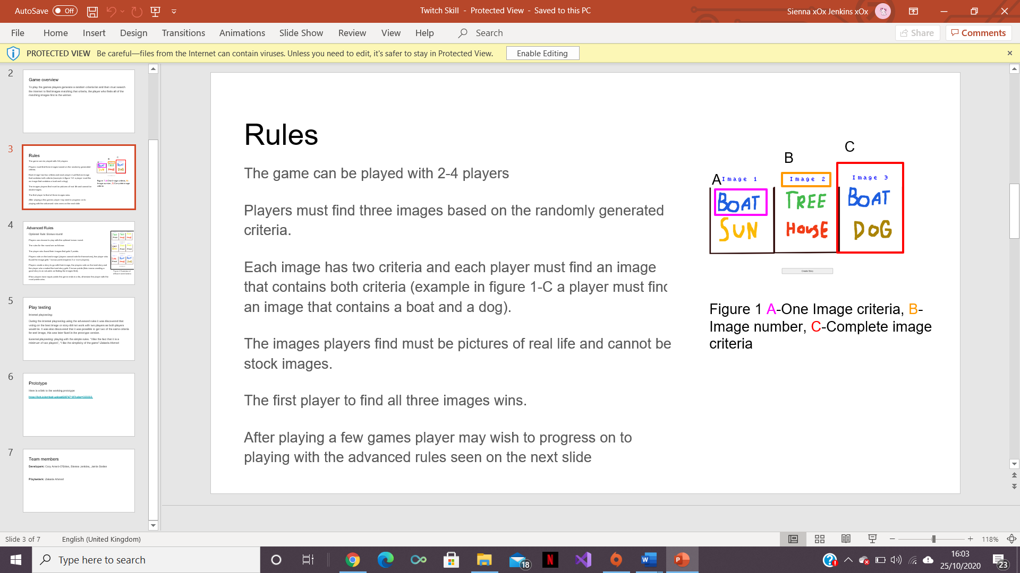 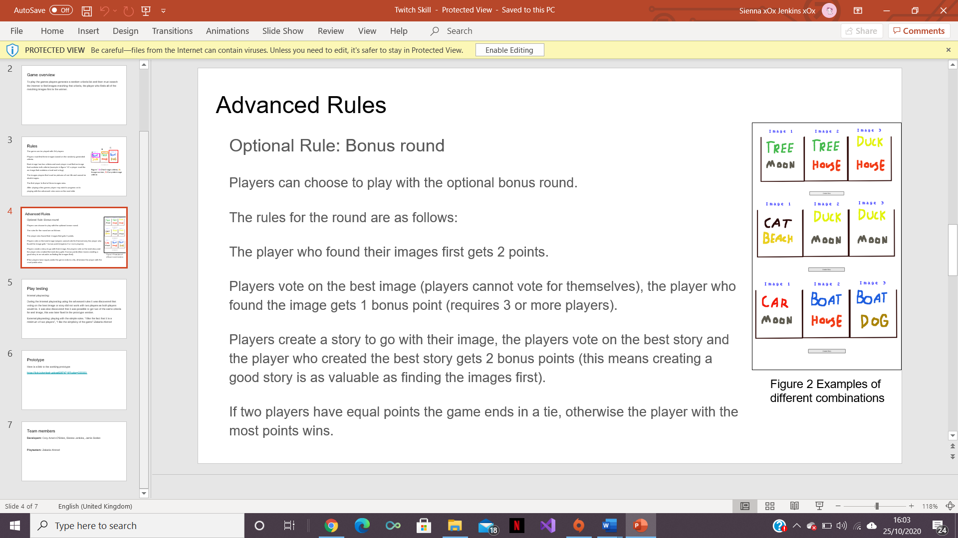

5.3 Play testing

Internal playtesting:

During the internal playtesting it was discovered that with the advanced rules the game did not work with less than 3 players as the game would always end in a tie. This was because when voting the players would have to vote for each other meaning they would both end up with the same number of votes. It was also discovered that it was possible for the criteria to be the same for an image which was later fixed.

External playtesting:

The team was told by the play testers that the game was good with the simple rules and it was good that there could be a minimum of two players.

5.4 Teamwork

Working in a team was helpful as the team could all pool ideas together to create a game with less holes in the functionality. Also, it made the game development quicker as the team could work on different parts of the game at different times.

Developers:

Cory Arnett-O’Brien,

Sienna Jenkins

And Jamie Soden

Playtesters:

Zakaria Ahmed